**Without Gini**

**Model - Random effects: beta ~ 1 | country_name**

**Start values**

fixed = a + b + alpha + beta ~ 1,

random = beta ~ 1 | country_name,

start = c(a = 5000, b = 0.1, alpha = 1, beta = 0.001)

Exlcuded countries – UAE, Luxembourg

Model Summary

===============================================

Dependent variable:

---------------------------

ES_pcap

-----------------------------------------------

a 12,609.990***

(95.773)

b -7.554***

(0.442)

alpha 3.839***

(0.033)

beta 0.00004***

(0.00000)

-----------------------------------------------

Observations 4,292

Log Likelihood -32,825.570

Akaike Inf. Crit. 65,663.150

Bayesian Inf. Crit. 65,701.340

===============================================

Note: *p<0.1; **p<0.05; ***p<0.01

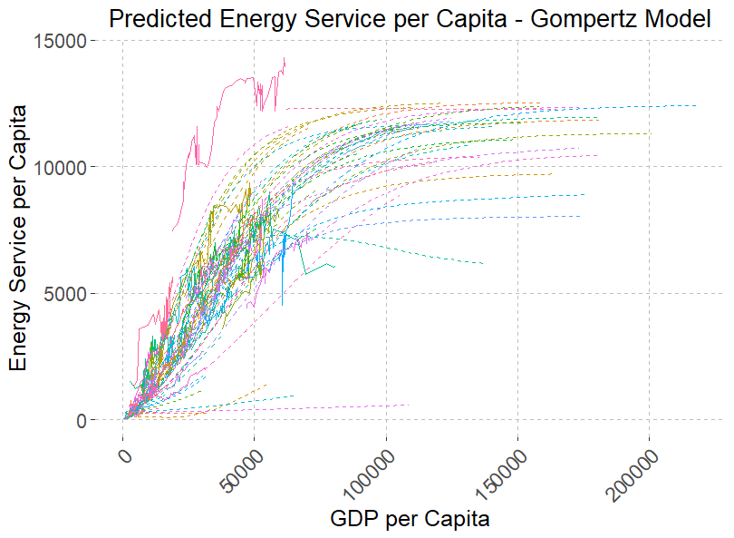

**Gini – old**

**Model 1 - Random effects: beta ~ 1 | country_name**

**Start values**

fixed = a + b + alpha + beta ~ 1,

random = beta ~ 1 | country_name,

start = c(a = 5000, b = 0.01, alpha = 1, beta = 0.001)

Exlcuded countries – UAE, Luxembourg

Model Summary

===============================================

Dependent variable:

---------------------------

ES_pcap

-----------------------------------------------

a 12,947.080***

(112.794)

b -8.101***

(0.655)

alpha 0.093***

(0.001)

beta 0.00003***

(0.00000)

-----------------------------------------------

Observations 2,351

Log Likelihood -18,127.330

Akaike Inf. Crit. 36,266.650

Bayesian Inf. Crit. 36,301.220

===============================================

Note: *p<0.1; **p<0.05; ***p<0.01

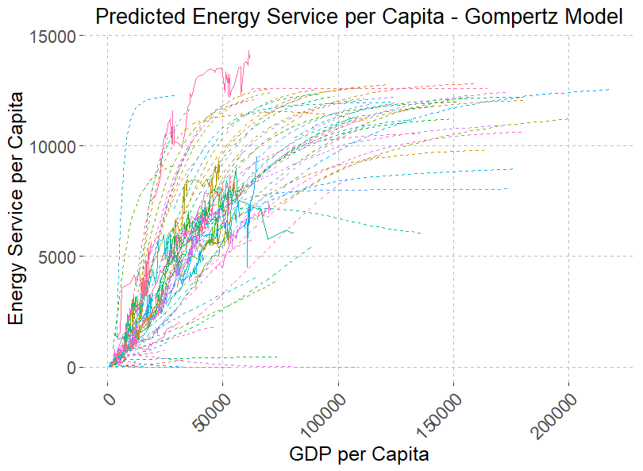

**Gini – old**

**Model 2 - Random effects: alpha ~ 1 | country_name**

**Start values**

fixed = a + b + alpha + beta ~ 1,

random = alpha ~ 1 | country_name,

start = c(a = 5000, b = 0.01, alpha = 1, beta = 0.001)

Exlcuded countries – UAE, Luxembourg

Model Summary

===============================================

Dependent variable:

---------------------------

ES_pcap

-----------------------------------------------

a 13,404.790***

(239.193)

b -3.628***

(0.761)

alpha 0.098***

(0.005)

beta 0.00003***

(0.00000)

-----------------------------------------------

Observations 2,351

Log Likelihood -18,224.040

Akaike Inf. Crit. 36,460.080

Bayesian Inf. Crit. 36,494.650

===============================================

Note: *p<0.1; **p<0.05; ***p<0.01

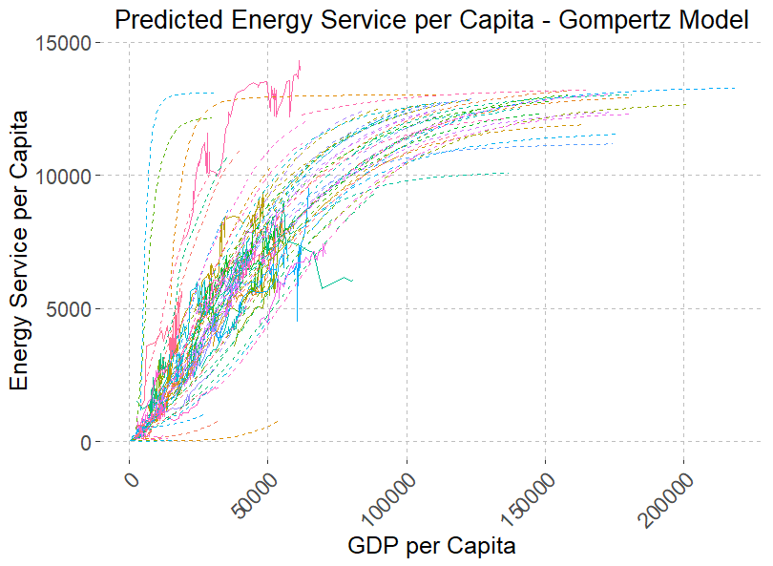

**Gini – case 1**

**Model 1 - Random effects: beta ~ 1 | country_name**

**Start values**

fixed = a + b + alpha + beta ~ 1,

random = beta ~ 1 | country_name,

start = c(a = 5000, b = 0.01, alpha = 1, beta = 0.001)

Exlcuded countries – UAE, Luxembourg

Model Summary

===============================================

Dependent variable:

---------------------------

ES_pcap

-----------------------------------------------

a 12,583.850***

(97.639)

b -7.214***

(0.500)

alpha 0.111***

(0.001)

beta 0.00005***

(0.00000)

-----------------------------------------------

Observations 4,292

Log Likelihood -32,916.750

Akaike Inf. Crit. 65,845.490

Bayesian Inf. Crit. 65,883.680

===============================================

Note: *p<0.1; **p<0.05; ***p<0.01

